Task Documentation

Technology Used :

- Djnago
- React
- Rest Framework
- Docker(For Running)
- Drf_yasg(Swagger UI)

1 . Project Setup :
- Run the Djnago-allauth locally ( https://github.com/tenthspire/django-allauth/tree/main/examples/react-spa )
- Use Docker Desktop to run the project
- Docker-compose up

- Implement rest_framework and drf_yasg (Swagger Ui):
Reqirements.txt :--
django-allauth[mfa,socialaccount]>=65.3.1
qrcode >= 7.0.0
djangorestframework==3.15.2 # or the latest version
drf_yasg==1.21.8
django-filter>=24.3
djangorestframework-simplejwt==5.3.1
django-cors-headers==4.6.0

- Add user_type to User model :
- Create Superuser
- Make a user model
- Import AbstractUser from auth.models
- Add user_type (Admin, Merchant, Customer, Developer)
- Make a Product model to make a API and test it on Swagger UI
- Add - ./backend/users:/code/users # add this to docker-compose.yml backend part.

- Task Model :
- Make Task model
- Make API for Task model and test on Postman
- Add to admin side
- Make urls for create,list,update,delete
- Add - ./backend/task:/code/task to docker-compose.yml backend part
- Make views for create,list,update and delete Project
- Test API’s on Postman (Give bearer token to Authorization)
- Test for GET,POST,PUT,PATCH,DELETE

- Implementation of Task to dlango-allauth page :
Requirements : axios
- In frontend -> src -> project , make axiosConfig.js , Project.js.
- In axiosConfig.js handle authentication and token refreshing..
- In Project.js implement the code for CRUD operation.
- In src->account->Login.js set the token of Authentication.
- Add urls for project in Router.js .
- In Navbar.js add Project section from where all the CRUD operation are done.

- View of Implementation :

Dashboard page :

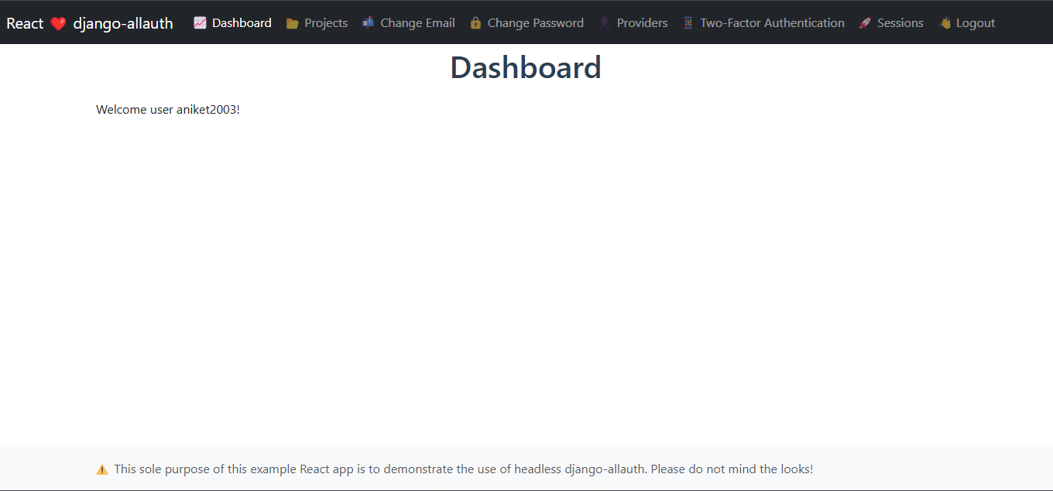

Project page and Creation of Project :

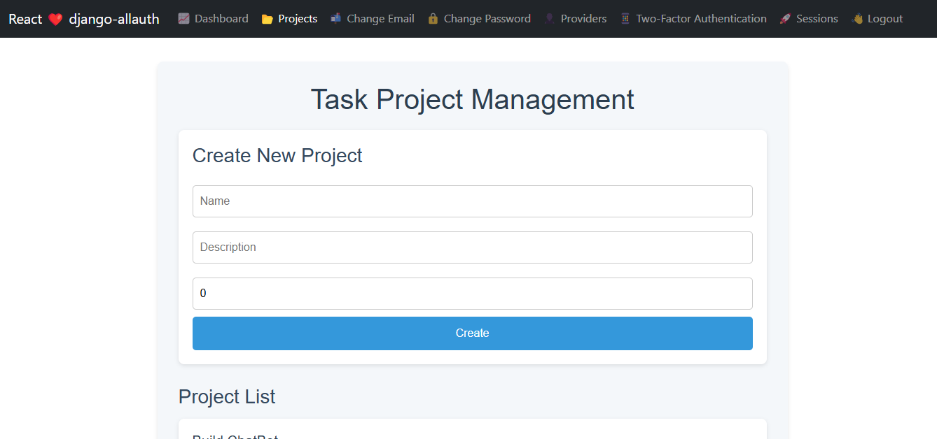

List of Project :

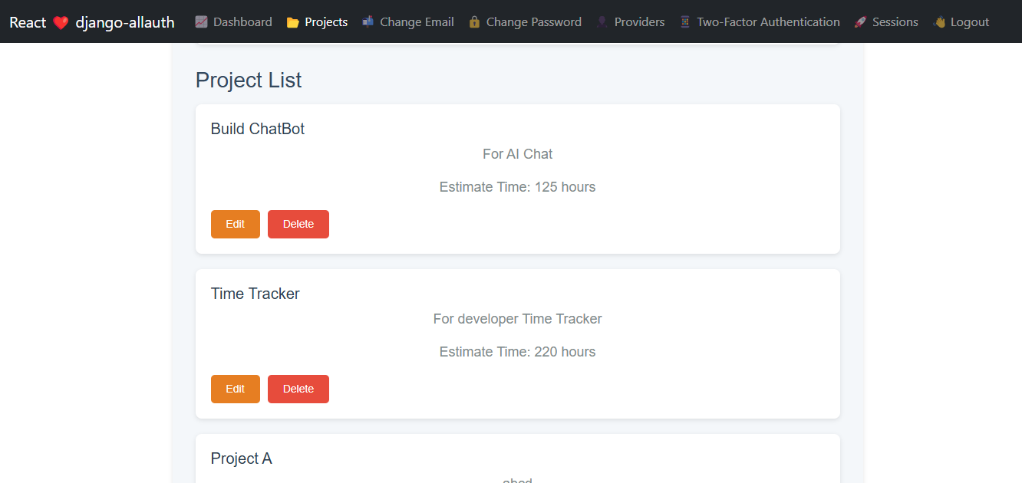

Update Project :

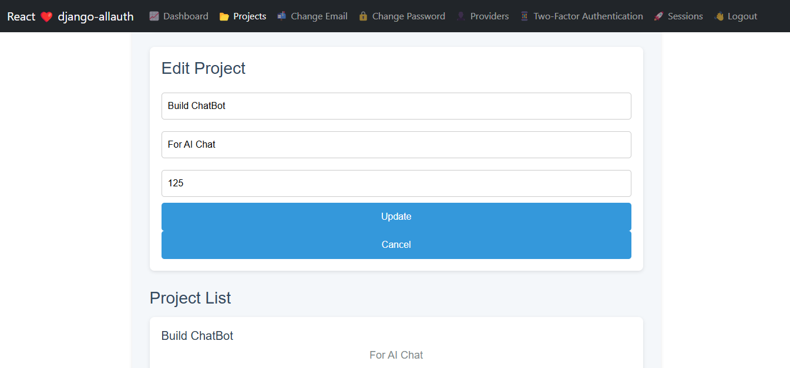

For run :

localhost : 10000 (Run actuall project)
Backend : localhost:8000
Frontend : localhost:3000

- Third Party Integration for Google :

- Add "allauth.socialaccount.providers.google" in settings.py -> Installed App
- Also add
SOCIALACCOUNT_PROVIDERS = {
'google': {
'SCOPE': [
'profile',
'email',
],
'AUTH_PARAMS': {
'access_type': 'online',
},
'OAUTH_PKCE_ENABLED': True,
}
- Then make app in Google Cloud and get Client ID and Client Secreat Key
- Use this id and key in admin->socialaccount->socialapp to add Google
- If get error fix with given URIs by google by adding it on Authories redirect URIs

For Facebook :
- Create Facebook App and get App Id

SOCIALACCOUNT_PROVIDERS = {
'facebook': {
'METHOD': 'oauth2', # Set to 'js_sdk' to use the Facebook connect SDK
'SDK_URL': '//connect.facebook.net/{locale}/sdk.js',
'SCOPE': ['email', 'public_profile'],
'AUTH_PARAMS': {'auth_type': 'reauthenticate'},
'INIT_PARAMS': {'cookie': True},
'FIELDS': [
'id',
'first_name',
'last_name',
'middle_name',
'name',
'name_format',
'picture',
'short_name'
],
'EXCHANGE_TOKEN': True,
'LOCALE_FUNC': 'path.to.callable',
'VERIFIED_EMAIL': False,
'VERSION': 'v13.0',
'GRAPH_API_URL': 'https://graph.facebook.com/v13.0',
}
}

Add this to settings.py file.
- Use this id and key in admin->socialaccount->socialapp to add Facebook

- Domains like GoDaddy and ResellerClub :

For GoDaddy :
- Get API Key and API Secrete from Login in GoDaddy
- Add it to settings.py file like :
    - GODADDY_API = {
"api_key": "our_apikey",
"api_secret": "our_secret",
"test_mode": True, # Change to False for live environment
}

- GODADDY_BASE_URL = "https://api.ote-godaddy.com" if GODADDY_API["test_mode"] else "https://api.godaddy.com"

- For testing OTE is there and for production api.godaddy.com is one.

- https://developer.godaddy.com/doc/endpoint/domains#/ For more details of domain availability , purchase swagger urls

-

